**Task 1 – User Story Mapping**

1. **Story of Choo Li Wey**

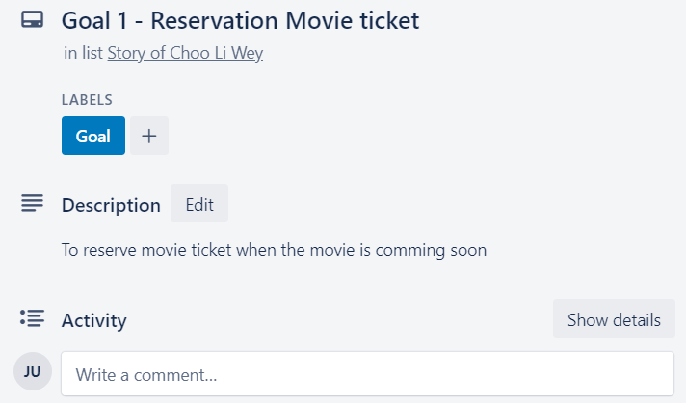

Description of Reservation Movie Ticket

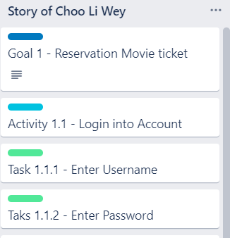

Activity 1.1 Login into Account

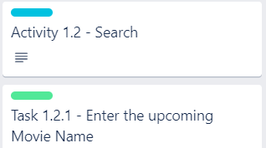

Activity 1.2 Search

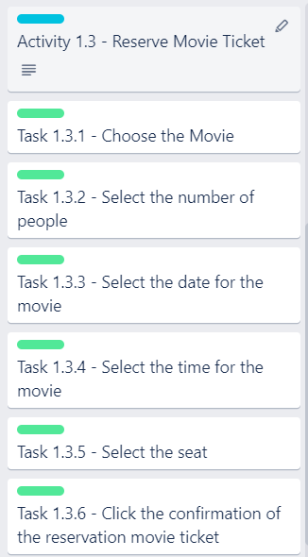

Activity 1.3 Reserve Movie Ticket

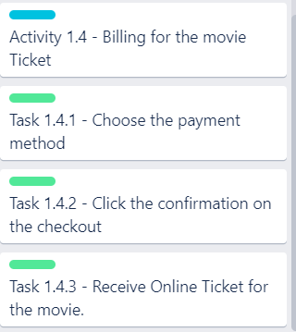

Activity 1.4 Billing for the movie ticket

1. **Story of Koay Lip Sheng**

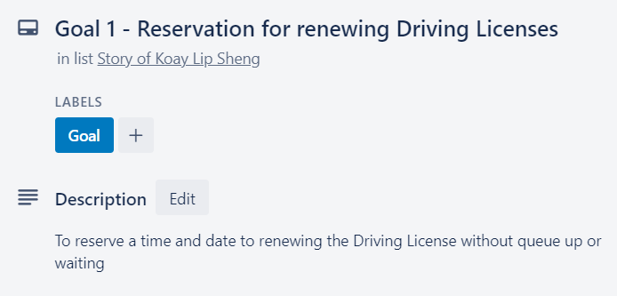

Description of Reservation for renewing Driving Licenses

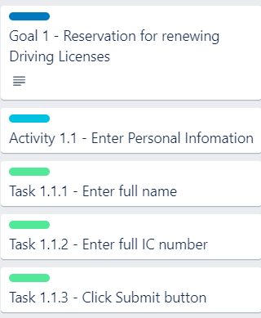

Activity 1.1 Enter Personal Information

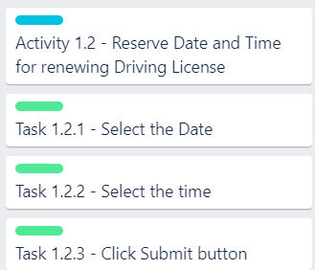

Activity 1.2 Reserve Date and Time for renewing Driving License

1. **Story of Mun Yi Jie**

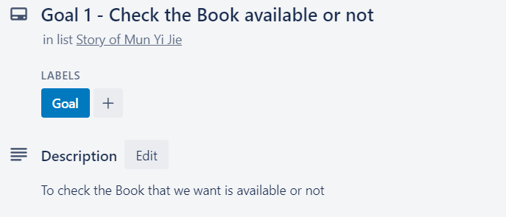

Description of Check the Book available or not

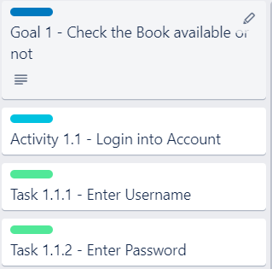

Activity 1.1 Login into Account

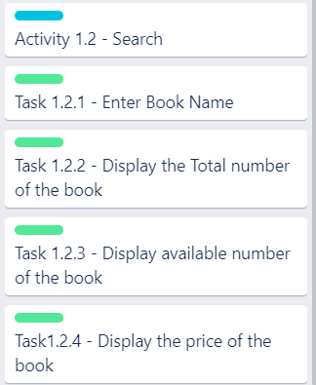

Activity 1.2 Search

1. **Story of Oh Kah Wei**

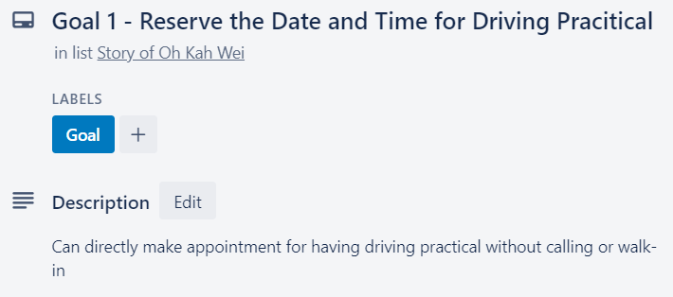

Description of Reservation of the date and time for Driving practical

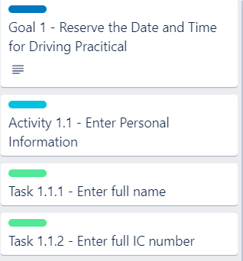

Activity 1.1 Enter Personal Information

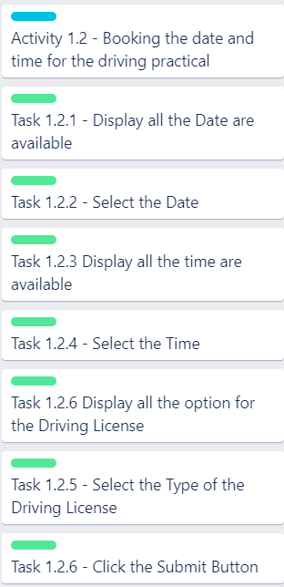

Activity 1.2 Make reservation for driving practical

1. **Story of Eric Sho Huan Jie**

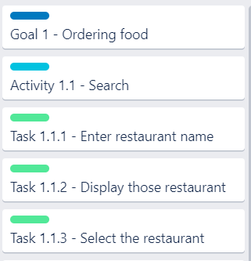

Activity 1.1 Search

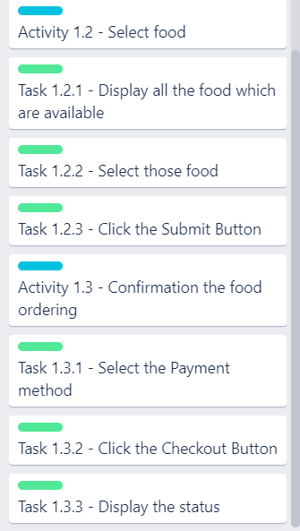

Activity 1.2 Select food

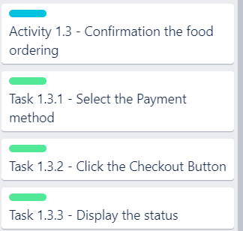

Activity 1.3 Confirmation for the food ordering